Instrumentation of Private Synthetic Agent (PSA) in Linux
Document to Refer
https://docs.appdynamics.com/appd/22.x/22.3/en/end-user-monitoring/synthetic-monitoring/install-the-private-synthetic-agent-web-and-api-monitoring/set-up-the-web-monitoring-psa-and-api-monitoring-psa-in-minikube

- Pre-requisite
https://docs.appdynamics.com/appd/23.x/latest/en/end-user-monitoring/synthetic-monitoring/install-the-private-synthetic-agent-web-and-api-monitoring

8 CPU
32 GB RAM
200 GB Storage

- PROXY settings
export HTTP_PROXY=http://<proxy hostname:port>
export HTTPS_PROXY=https://<proxy hostname:port>
export NO_PROXY=localhost,127.0.0.1,10.96.0.0/12,192.168.59.0/24,192.168.49.0/24,192.168.39.0/24

- Install Docker

systemctl start docker
systemctl status docker
Systemctl restart docker

- Install MiniKube using below command

curl -LO https://storage.googleapis.com/minikube/releases/latest/minikube-linux-amd64
sudo install minikube-linux-amd64 /usr/local/bin/minikube

- Start and check the status of MiniKube using below command

minikube start
minikube status

kubectl will be installed along with Minikube, just set the alias using below command

alias kubectl="minikube kubectl --"

We can use below command to access the cluster

kubectl get nodes

- Download the zip file for PSA installation from the Appdynamics Downloads. https://download.appdynamics.com/

- Build the images

We can build the images directly in the VM or we can pull a built image from docker hub.

For sum-chrome-agent:
- Unzip the zip file to access the sum-chrome-agent directory.
- Navigate to the directory and run the following command:
docker build -f Dockerfile-PSA -t sum-chrome-agent:<agent-tag> .
Note: <agent-tag> can be anything ex : v1

For sum-api-monitoring-agent:
- Unzip the zip file to access the sum-api-monitoring-agent directory.
- Navigate to the directory and run the following command:
docker build -f Dockerfile-PSA -t sum-api-monitoring-agent:<agent-tag> .
Note: <agent-tag> can be anything ex : v1

For sum-heimdall:
- Unzip the zip file to access the sum-heimdall directory.
- Navigate to this directory and run the following command:
docker build -f Dockerfile-PSA -t sum-heimdall:<heimdall-tag> .
Note: <agent-tag> can be anything ex : v1

OR We can pull from any Docker repository as below

docker pull visraj06/sum-chrome-agent:v1
docker tag visraj06/sum-chrome-agent:v1 sum-chrome-agent:v1

docker pull visraj06/sum-api-monitoring-agent:v1
docker tag visraj06/sum-api-monitoring-agent:v1 sum-api-monitoring-agent:v1

docker pull visraj06/sum-heimdall:v1
docker tag visraj06/sum-heimdall:v1 sum-heimdall:v1

- Save Images to Minikube's Docker Daemon (Loading the image)

docker save sum-heimdall:<heimdall-tag> | (eval $(minikube docker-env) && docker load)

docker save sum-chrome-agent:<agent-tag> | (eval $(minikube docker-env) && docker load)

docker save sum-api-monitoring-agent:<agent-tag> | (eval $(minikube docker-env) && docker load)

- Install Helm

https://helm.sh/docs/intro/install/
- Create a namespace and run the pod

kubectl create namespace measurement

helm show values sum-psa-heimdall.tgz > values.yaml

update the values of yml as shown in the below document

https://docs.appdynamics.com/appd/22.x/22.3/en/end-user-monitoring/synthetic-monitoring/install-the-private-synthetic-agent-web-and-api-monitoring/set-up-the-web-monitoring-psa-and-api-monitoring-psa-in-minikube

helm install heimdall-onprem sum-psa-heimdall.tgz --values values.yaml --namespace measurement

- Verify the pods running

kubectl get pods --namespace measurement

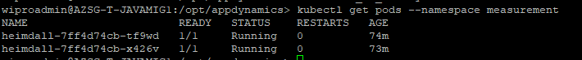

if you make any changes in the yml use below command to upgrade

helm upgrade heimdall-onprem sum-psa-heimdall.tgz --values values.yaml --namespace measurement

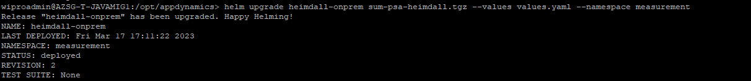

Private Synthetic Agent should show in the controller
- To check the logs in the pods

kubectl logs heimdall-84649498d8-rdjvw -n measurement

552 kubectl describe pod heimdall-84649498d8-rdjvw -n measurement

